ASSIGNMENT 7.5
M.Sanjay
2303A54036
Task 1 (Mutable Default Argument – Function Bug)
Task: Analyze given code where a mutable default argument causes unexpected behavior. Use AI to fix it.
# Bug: Mutable default argument

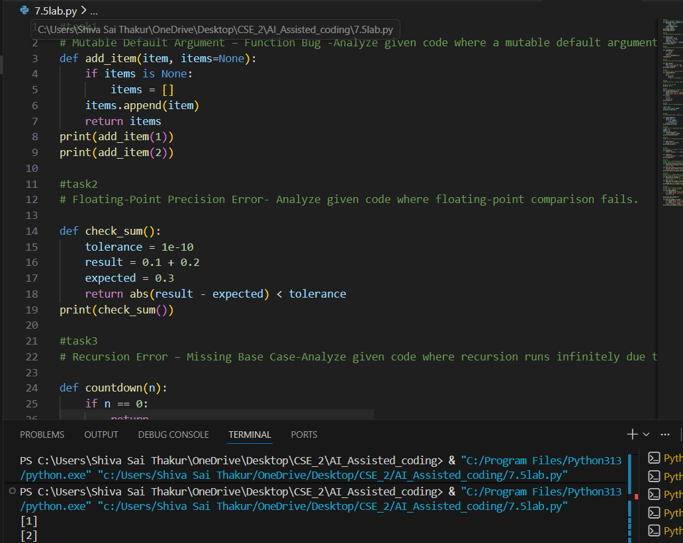
Task 2 (Floating-Point Precision Error)
Task: Analyze given code where floating-point comparison fails. Use AI to correct with tolerance.
# Bug: Floating point precision issue
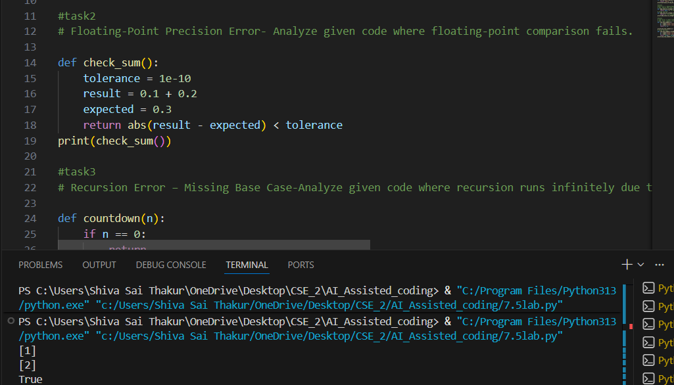
Task 3 (Recursion Error – Missing Base Case)
Task: Analyze given code where recursion runs infinitely due to missing base case. Use AI to fix.
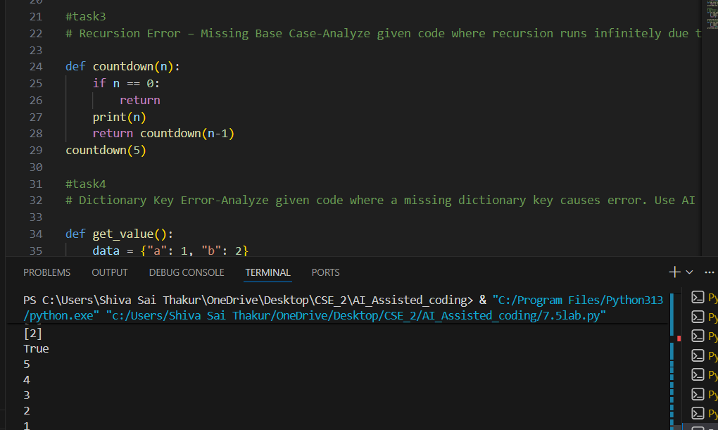
Task 4 (Dictionary Key Error)
Task: Analyze given code where a missing dictionary key causes error. Use AI to fix it.
# Bug: Accessing non-existing key
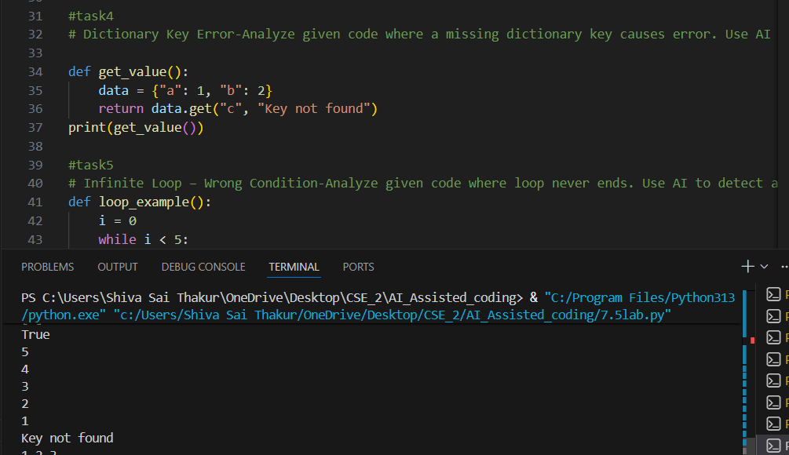
Task 5 (Infinite Loop – Wrong Condition)
Task: Analyze given code where loop never ends. Use AI to detect and fix it.
# Bug: Infinite loop
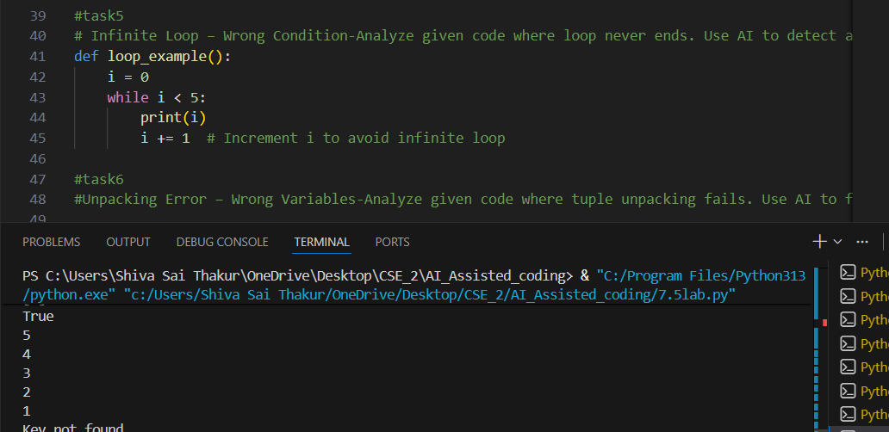
Task 6 (Unpacking Error – Wrong Variables)
Task: Analyze given code where tuple unpacking fails. Use AI to fix it.
# Bug: Wrong unpacking
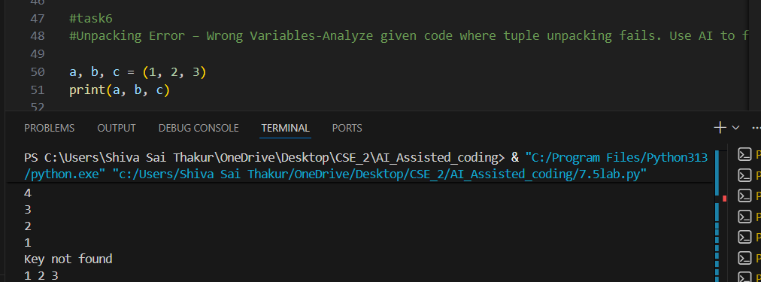
Task 7 (Mixed Indentation – Tabs vs Spaces)
Task: Analyze given code where mixed indentation breaks execution. Use AI to fix it.
# Bug: Mixed indentation
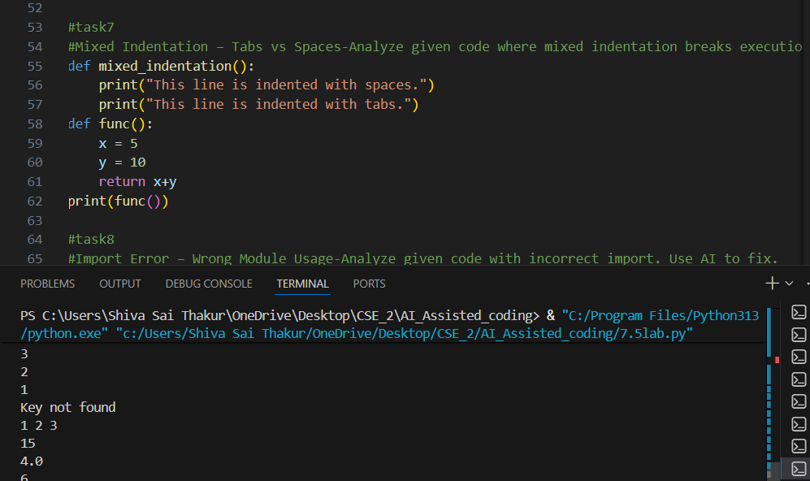
Task 8 (Import Error – Wrong Module Usage)
Task: Analyze given code with incorrect import. Use AI to fix.
# Bug: Wrong import
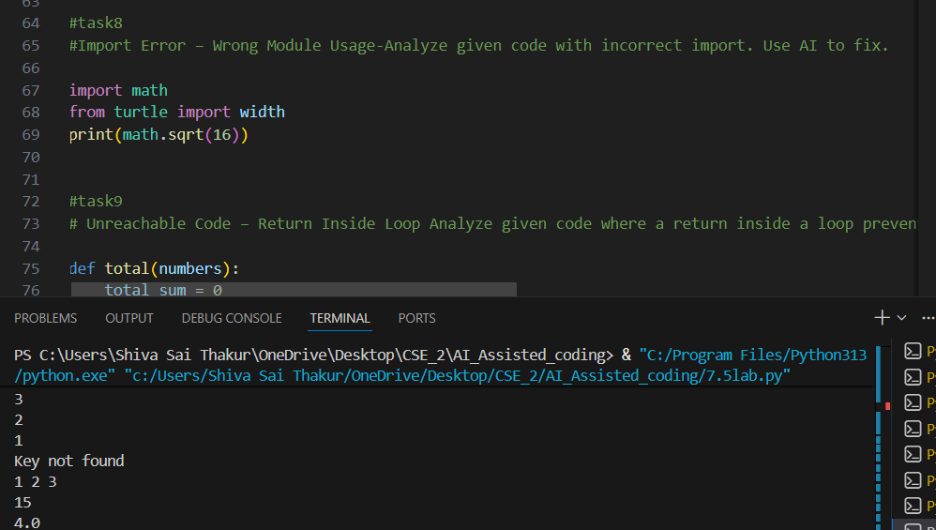
Task 9 (Unreachable Code – Return Inside Loop)
Task: Analyze given code where a return inside a loop prevents full iteration. Use AI to fix it.
# Bug: Early return inside loop

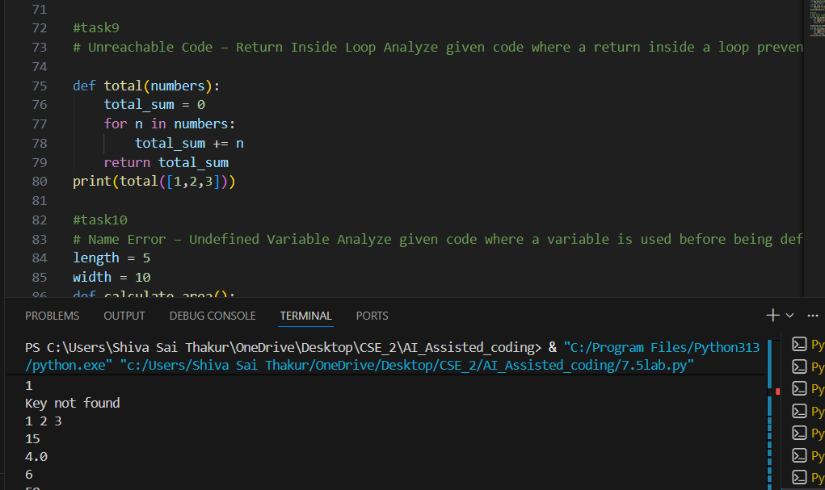

Task 10 (Name Error – Undefined Variable)
Task: Analyze given code where a variable is used before being defined. Let AI detect and fix the error.
# Bug: Using undefined variable
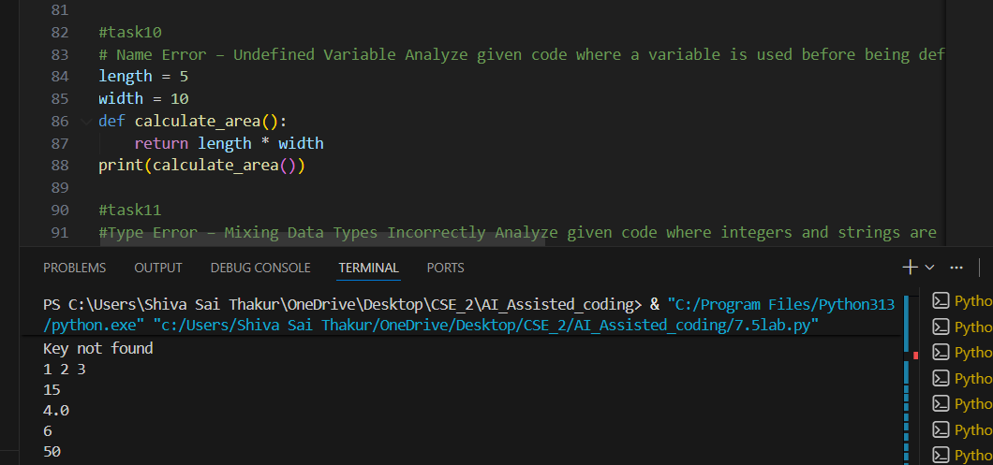
Task 11 (Type Error – Mixing Data Types Incorrectly)
Task: Analyze given code where integers and strings are added incorrectly. Let AI detect and fix the error.
# Bug: Adding integer and string
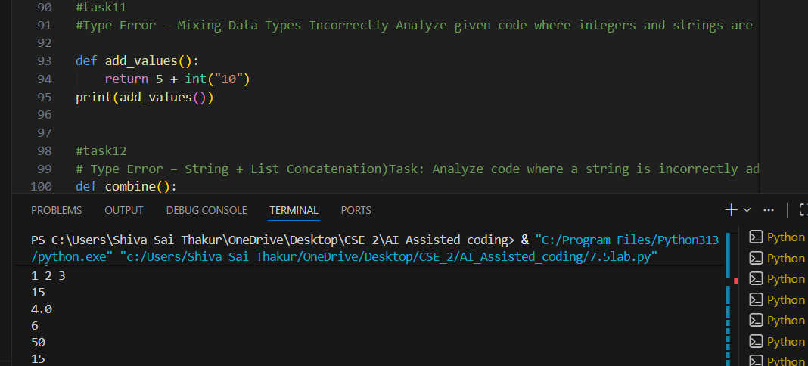
Task 12 (Type Error – String + List Concatenation)
Task: Analyze code where a string is incorrectly added to a list.
# Bug: Adding string and list
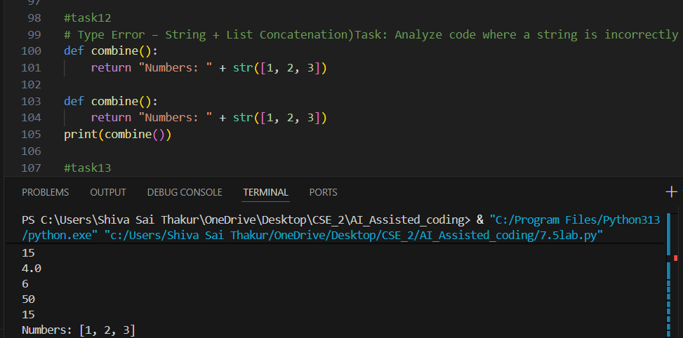
Task 13 (Type Error – Multiplying String by Float)
Task: Detect and fix code where a string is multiplied by a float.
# Bug: Multiplying string by float
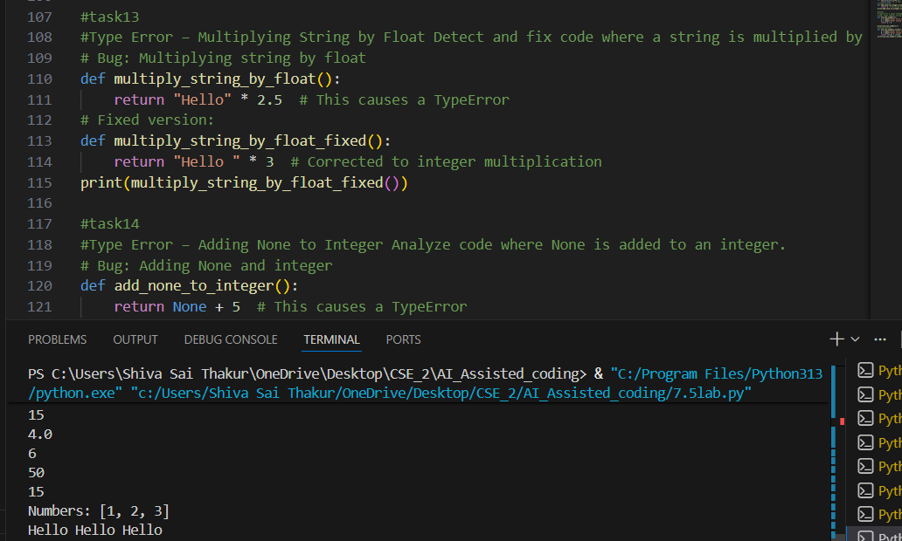
Task 14 (Type Error – Adding None to Integer)
Task: Analyze code where None is added to an integer.
# Bug: Adding None and integer
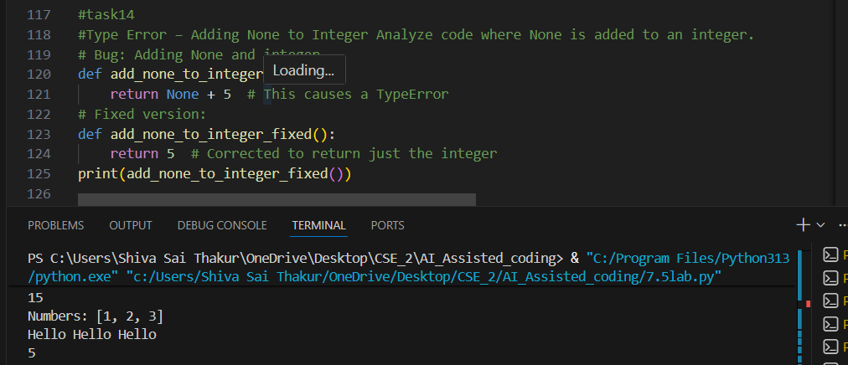
Task 15 (Type Error – Input Treated as String Instead of Number)
Task: Fix code where user input is not converted properly.
# Bug: Input remains string
